**Informatics Institute of Technology**

in collaboration with

**University of Westminster, UK**

**GOPIT**

**5COSC009C: Software Development Group Project**

Module Leader-Mr. Banu Athuraliya

**BENG(Hons)Software Engineering/BSc (Hons)Computer Science**

Department of Computing

|  |  |  |  |  |  |  |  |  |  |  |  |  |  |  |  |  |  |  |  |  |  |
| --- | --- | --- | --- | --- | --- | --- | --- | --- | --- | --- | --- | --- | --- | --- | --- | --- | --- | --- | --- | --- | --- |
| **Team Caffeine Brains**   |  |  |  | | --- | --- | --- | | **Name** | **IIT Number** | **UOW Number** | | H. B. D. S. Hewawasam | 2019944 | W1790957 | | I. C. Ilamperuma | 2019921 | W1790901 | | H. R. S. Hasaranga | 2019929 | W1790951 | | M. M. Mandara | 2019950 | W1790906 | | R. S. W. B. C. Ranathunga | 2019923 | W1790948 | | W. S. H. Miniruwan | 2019928 | W1790950 | |

Contents

1.7 Resource Requirements 3

1.7.1 Hardware Requirements 3

1.7.2 Software Requirements 3

1.7.3 Technology Stack 4

Chapter 06 – Implementation 6

6.1 Chapter Overview 6

6.2 Overview of the prototype 6

6.3 Technology Selections 6

6.3.1 Language Selection 6

6.3.2 Libraries / Frameworks selection 7

6.3.3 Summary of Components in GOPIT 7

6.4 Dataset 7

6.5 Implementation of the features of the prototype in the backend 8

6.5.4 Testing and Model using review. 8

6.5.4 Categorization of issue 8

6.6 Implementation of Graphical User Interface (GUI) 8

6.6.1 Implementation of First Window (App Loading window) 8

6.7 Combining of the backend and Frontend. 8

6.7 Chapter Summary 8

Reference 8

# 1.7 Resource Requirements

The following section details the resource requirements for GoPit application.

## 1.7.1 Hardware Requirements

|  |  |
| --- | --- |
| **Device** | **Specifications** |
| Huawei Y7p | Android 9.0 (Pie), EMUI 9, Kirin 710F (12 nm) chipset, Octa-core (4x2.2 GHz Cortex-A73 & 4x1.7 GHz Cortex-A53), 4GB Ram, 64GB Internal Memory |
| Samsung Galaxy A51 | Android 11, One UI version 3.0, Exynox 9611 (10nm) chipset, Octa-core (4x2.3 GHz Cortex-A73 & 4x1.7 GHz-Cortex-A53), 6GB Ram, 128GB Internal Memory |
| Oppo F9 Model CPH1823 | Android 10, ColorOS 7.0, Mediatek MT6771 Helio P60 (12nm) chipset, Octa-core (4x2.0 GHz Cortex-A73 & 4x2.0 GHz Cortex-A53), 4GB Ram, 64 GB Internal Memory |
| Dialog 4G router/ Bell 4G router (Internet Connection) – Fast Internet connection | LTE model: tozed ZLP P28 |

## 1.7.2 Software Requirements

From the initial research, it was identified that the following languages, IDEs, Other software, APIs and Libraries will be needed for the successful completion of the project.

|  |  |
| --- | --- |
| **Languages** | |
| Python (V3.9) | For machine learning backend |
| Java (V11) | For main backend programming |
| C++ (C ++ 20 ) | For secondary backend programming |
| **IDEs and Other Software** | |
| Anaconda (V2020.07) | Python package management system |
| Jupyter Notebook (V6.1.6) | For programming backend while documenting |
| PyCharm (V2020.3.2) | For programming with Python with OOP |
| Teachable Machine | For create machine learning model |
| Android Studio (V4.1) | For programming with Java and develop the project |
| StarUML (V3.2.2) | For creating UML and Use case diagrams |
| Microsoft Office Word (V2020) | For making the reports and other documentations |
| https://www.gantt.com/ | For making the Gantt chart diagrams |
| Adobe Photoshop (CC 2017) | For editing and creating images and wireframes |
| Google Drive | For managing the documents and data in the cloud |
| Git (V2.30.0) | For version controlling |
| Jira(V8.16.8.0) | For project management system |
| Microsoft Teams | For corporate among the group |
| **APIs, Libraries and Frameworks** | |
| Pandas (V0.20.3) | For data analysis |
| Tensorflow(V2.4.1) | Machine Learning library with pre-built algorithms |
| Pickle (V3) | For serialization of data |

## 1.7.3 Technology Stack

The technology stack is a set of tools and frameworks that are used in the development of a software product. In software development, the technology stack consists of a very specific set of components that work together to create a functioning web application. (da-14.com, n.d.)

Technology stack in mobile application development can be divided into four areas. They are,

1. **Frontend Development**

This is the interface on which users interact with the mobile application.

1. **Backend Development**

Tools and software needed to create the underlying processing on the server.

1. **Development Platform**

A consolidated platform that provides the necessary libraries and interfaces to build the application.

1. **Additional (Supporting)**

Various tools and technologies that improve the security, flexibility, and performance of the application.

Technology stack for any mobile application depends on the platform that application is targeting. There are four types of technology stacks in mobile application development. They are **Android app technology stack, IOS app technology stack, Hybrid app technology stack** and **Cross-platform app technology stack.**

Among those technology stack types, **Android app technology stack** is chosen for the development of the GoPit application.

**Front-end, or Client-side**

The front-end components enable the user’s interaction with the application. GoTit application can be developed more user friendly with following components.

* **Fragments** are used to pass information between app screens. each screen of the app is associated with one or more fragments. Fragment represents a reusable portion of the app UI.
* **Layout Editor** is used to define and modify the layout either by coding XML or using the interactive visual editor.
* **XML drawables** are used to describe shapes, state, transitions of the application. it is used to decorate the application.

**Java** is the default language of the **Android Studio IDE**. Android OS is Linux kernel and it handles the memory management and the networking requirements for the device. Java is portable and it is capable of running on the ARM, X86 or MIPS processors. Java is an object-oriented language with much flexibility; it increases the code reusability and the security of the application. Most enterprise level mobile applications are developed using Java and there are a huge amount of supportive communities to get some help for development. In the opinion of many experts in mobile application development, Java is the most suitable language for android application developing.

**Back-end, or Server-side**

The back-end part of the development stack includes more components, and there are many more options to choose from here. Back-end works behind the scenes and is invisible to users, but it forms the engine that drives the application and implements its business logic. All back-end tech stacks include the following main parts:

* **Operating system** in which the development is done.
* Web server processing requests from the browser and returning the corresponding content.
* **Database** storing the app data.
* **Programming language** used to create the app code.

# Chapter 06 – Implementation

## 6.1 Chapter Overview

In this chapter overview before the implementation overview must mention that we changed our project scope. Because of the lack of proper data set and the use of data science does not happen much.

Before changed the scope we informed that issue to our module leader as instructed by the tutor.

In this implementation chapter will focus on the selected programming languages, libraries and frameworks and technologies that were used for implementing the GoPit app. And will discuss how one by one the features developed in the GoPit app with relevant code snipped and screenshots.

In addition, the challenges faced in implementing features and the solutions used are discussed in this chapter.

## 6.2 Overview of the prototype

* In the main backend, an image that is uploaded or captured at that moment is inserted into the system, analyzed according to the data set included in the system.
* After analyzing the data system will and divide them according to categories and display the result in the display result window.
* Mainly in the frontend has been developed by using android studio, in their it developed by using xml.

## 6.3 Technology Selections

After creating all the programming languages that can be used to create the GoPit app, java was selected as the main language. GoPit’s technology selection is divided in to two parts and discussed here.

Those are language selection and libraries and framework selection.

### 6.3.1 Language Selection

Java Language was selected for the following reasons,

* Java based on Object Oriented Programming language and It is easy to reuse the code.
* GoPit app is a mobile application. And mostly android development and java development is similar.
* It can edit easy.
* Configurations, Its high memory, high performance.
* Java is an excellent multifunctional IDE.
* It is easy to track the errors because it is statistically built language.
* It has capacity to perform multitask.
* If JVM is installed on the device, then the security is enhanced. (FITA,2018)
* Easy to find tutorials and good support for machine learning.
* Team members have good knowledge of java programming language and have a huge community to get the support.

Kotlin and Python languages are selected as secondary languages. Python language is most related to the machine learning implementations and It gives a good support to machine learning. Therefore, python language was selected for the machine learning part of GoPit project implementations.

Kotlin language was selected to create the real time camera in this GoPit app and Kotlin gives for good support for machine learning.

### 6.3.2 Libraries / Frameworks and Tools selections

#### 6.3.2.1 TensorFlow

TensorFlow is a Google’s open-source AI based framework used for training the machine learning model. To train the machine learning model on GoPit implementation selected TensorFlow. When use android studio IDE to develop GoPit application, can use TensorFlow as a plugin.

#### 6.3.2.2 TFLite Model Maker

#### 6.3.2.3 Junit

Junit is an open-source testing framework for java programmers. For Implementations of the GoPit app mainly will use java programming language. So, for the testing of the GoPit application it is easy to use Junit framework.

#### 6.3.2.4 Matplotlib

Matplotlib is a python library that is used for plotting graphs and visualize the result. In this GoPit project it is used for visualizing the backend result.

#### 6.3.2.5 android. Core

#### 6.3.2.6 android. Camarax

#### 6.3.2.7 NumPy

NumPy is a python library. That provides a multidimensional array object, various derived objects (such as masked arrays and matrices), and an assortment of routines for fast operations on arrays, including mathematical, logical, shape manipulation, sorting, selecting, I/O, discrete Fourier transforms, basic linear algebra, basic statistical operations, random simulation and much more. (NumPy Documentation — NumPy v1.20 Manual, 2021)

NumPy is used for back-End implementation of GoPit project.

#### 6.3.2.8 Teachable Machine

### 6.3.3 Summary of Components in GoPit

### 

|  |  |  |
| --- | --- | --- |
| Requirement | Feature | Completion |
| 01 | Upload photo from gallery | Done |
| 02 | Gallery access | Done |
| 03 | Take a photo | Done |
| 04 | Access to Phone camera | Done |
| 05 | Get the photo to the system that took by camera | Done |
| 06 | Real time camara scan | Done |
| 07 | Show correct result | Done |

## 6.4 Dataset

A garbage classification dataset that is released under garbage on Kaggle was initially used for GoPit project. Data set includes 15,550 images from 12 different classes of Garbage.

GoPit app implements based on restaurant domain. So, for GoPit app do not need all the data include in the garbage classification dataset. So, had to clean the original data set as required by the GoPit app.

The data set created after cleaning the original data set contains only six garbage classes. Those are Glass, Hazardous, Metal, Plastic, Organic and Recyclable.

## 6.5 Implementation of the features of the prototype in the backend

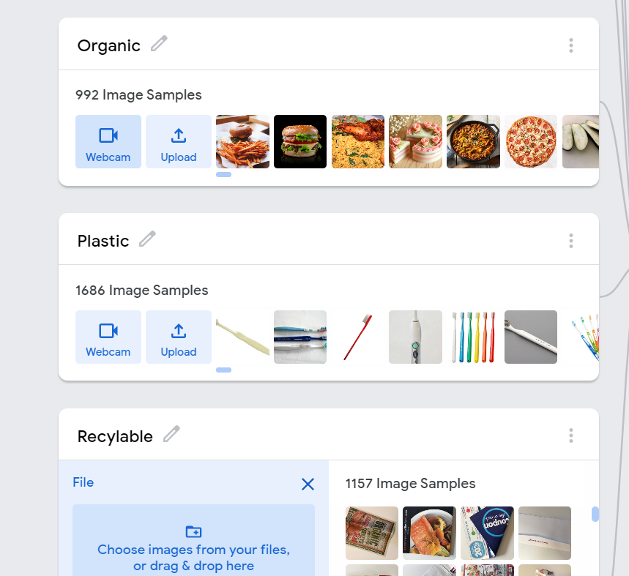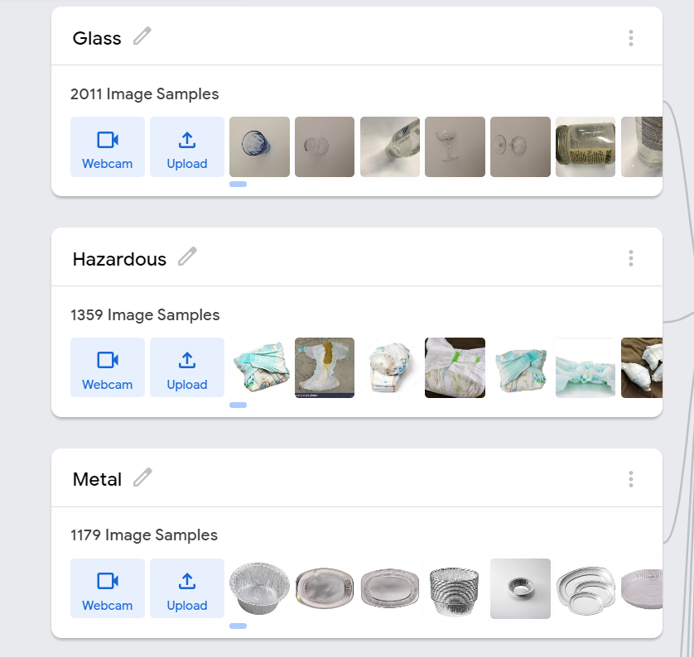

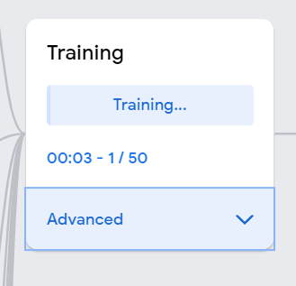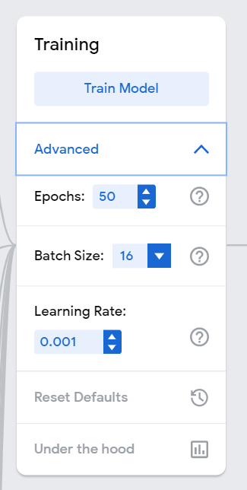

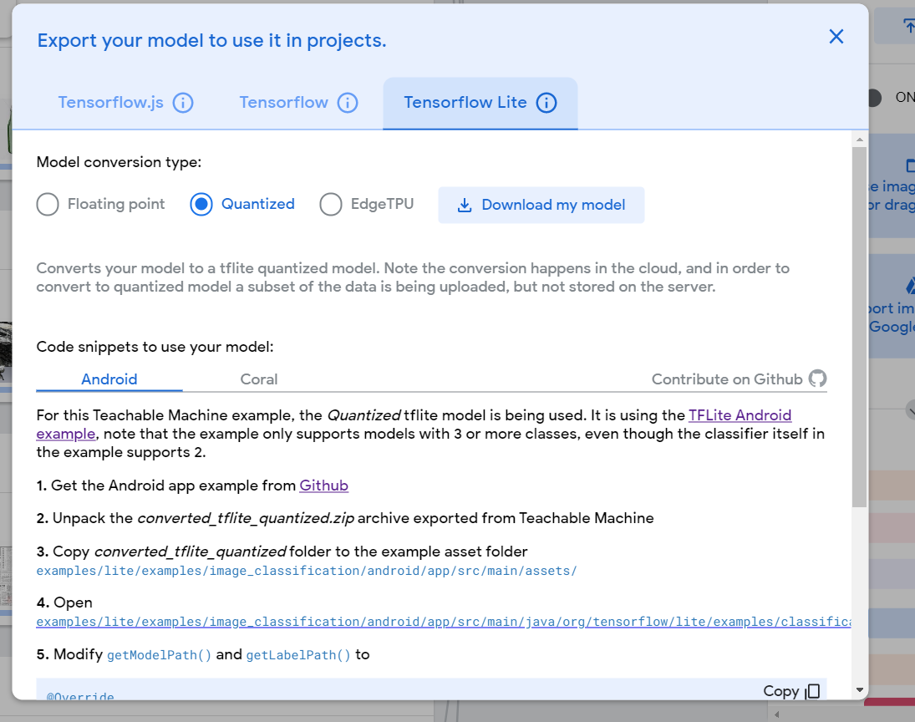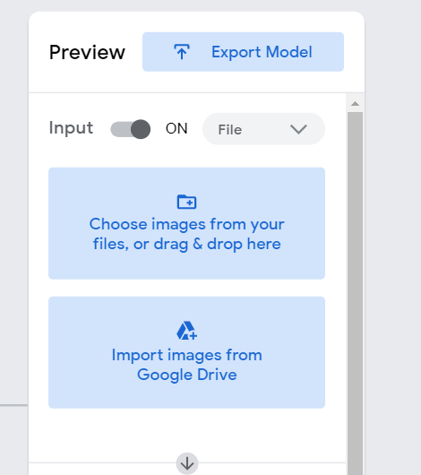

#### Challenges Encountered and Solutions

### 6.5.4 Testing and Model using review.

#### Challenges Encountered and Solutions

### 6.5.4 Categorization of issue

#### Challenges Encountered and Solutions

## 6.6 Implementation of Graphical User Interface (GUI)

#### Challenges Encountered and Solutions

### 6.6.1 Implementation of First Window (App Loading window)

## 6.7 Combining of the backend and Frontend.

As discussed in chapter 6.5, two TensorFlow Lite models were used for this project. There are two tflite model files and two text files includes the labels of the classes as a backend component. Finally, the backend and frontend components of the GoPiT project were combined by adding those text files to assets directory in the Android studio project and adding those tflite model files to ml directory in the android studio project. Figure # and figure # is showing the final file structure of the GoPiT project.

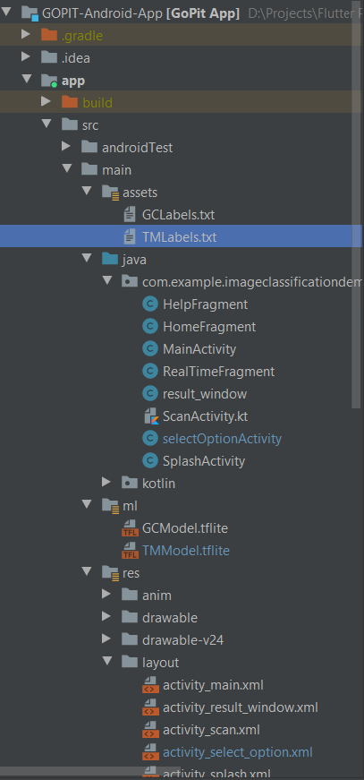

Controllers (Java & Kotlin files to control XML files)

Exported TFLite Models

Views (XML Files)

Exported Label files of TFLite files.

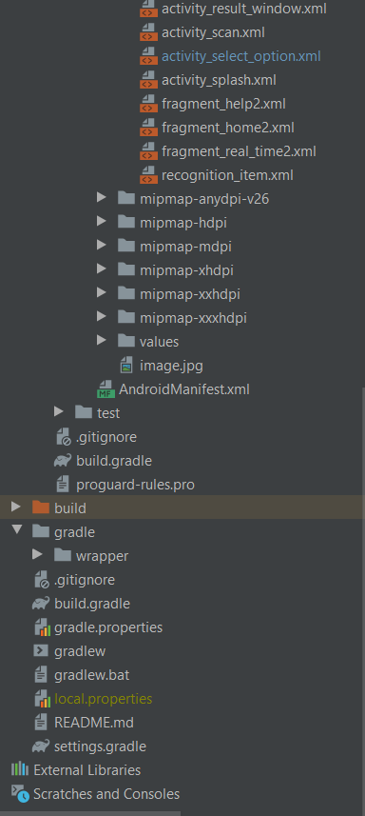

Views (XML Files)

Unit Tests

Build.gradle file

## 

Following code display the way that model which exported from Google Teachable machine, connecting to the GoPiT project.

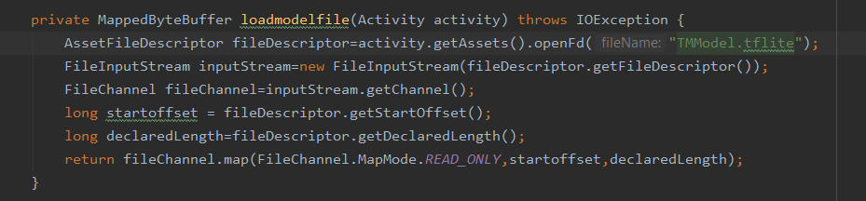

Figure # displays the way that how to connect to the Label text file (which exported from the Google Teachable machine) to the project.

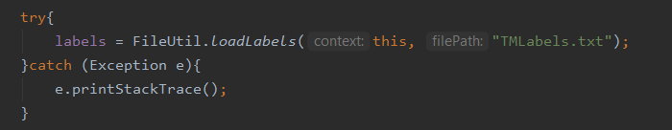

By creating the new instance of the model which trained by using Google Collab, after that it connected to the GoPiT project. Following code displays that incident.

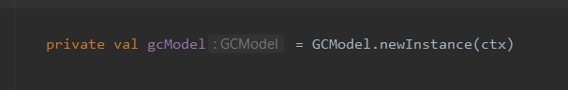

To the implementation of the GoPiT project, as a version control system, group members used the GitHub. created repository is free public repository. And the screenshots of the commits displayed in the Appendix #.

## 6.7 Chapter Summary

**Functional Requirements**

In the below two charts depicts the functional and Non-functional requirements of the system along with their priority levels.

* Critical - The requirements that are critically needed for successful completion of the project
* Medium - The requirements that are needed for a value-added completion of the project
* Low - The requirements that are needed for extra value for the project. Not mandatory

|  |  |  |  |
| --- | --- | --- | --- |
| **No** | **Requirement List** | **Priority Level** | **Description** |
| FR1 | Upload images which are stored in device storage. | Critical | The application should be able to upload garbage images which are already stored in mobile device storage |
| FR2 | Real-Time camera feature | Critical | The system should be able to turn on mobile camera and analyze real time images by showing their garbage classes with percentages. |
| FR3 | Display selected image from device storage in Image view Window | Critical | After selecting image from device, it should be automatically display in image view on application. |
| FR4 | Analyze given image and show relevant garbage classification class | Critical | Should be able to display classification class name of garbage as a text after analyzing. |
| FR5 | Show relevant garbage bin | Medium | The application automatically shown up relevant garbage bin according to the given image. |
| FR6 | Show help window | Low | Should be able to show initial steps which are wanting to be followed. |

**Non – Functional Requirements**

The following table explain the Non – Functional requirements of the system.

|  |  |  |  |
| --- | --- | --- | --- |
| **No** | **Requirement List** | **Priority Level** | **Description** |
| NF1 | Accuracy | Critical | The system should have a high level of accuracy when identifying garbage classification classes regarding to images. |
| NF2 | Reliability | Critical | The system should be reliable for hotels and the other users to classify garbages. |
| NF3 | Performance | Critical | The application should be well-performed without any considerable lagging issue and slowness |
| NF4 | Usability | Medium | The system should have mobile friendly ,proper navigation and user-friendly interfaces. |
| NF5 | Extensibility | Critical | The system should be able to analyze the image and identify the correct category of garbage |

## Reference

Kaggle.com. 2021. *Kaggle: Your Machine Learning and Data Science Community*. [online] Available at: <https://www.kaggle.com/> [Accessed 1 April 2021].

FITA. 2021. *Why is Java highly suitable for mobile application?* [online] Available at: <https://www.fita.in/java-highly-suitable-mobile-application/> [Accessed 8 March 2021].

TensorFlow. 2021. *TensorFlow*. [online] Available at: <https://www.tensorflow.org/> [Accessed 14 March 2021].

Numpy.org. 2021. *NumPy Documentation — NumPy v1.20 Manual*. [online] Available at: <https://numpy.org/doc/stable/contents.html#> [Accessed 1 April 2021].